Install beafortforLOL font in Z/Z/Files

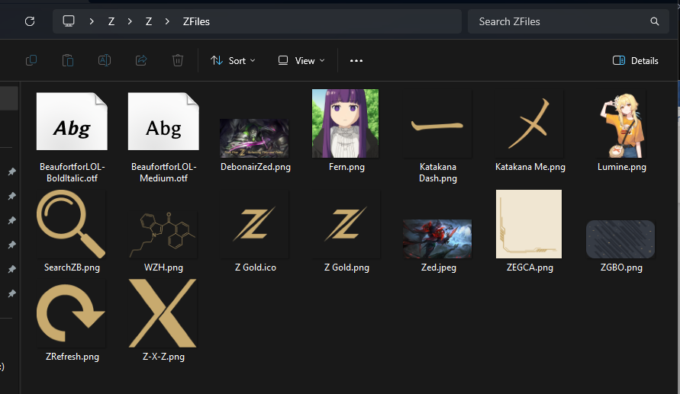

Double Click The Zdatabase.mdf

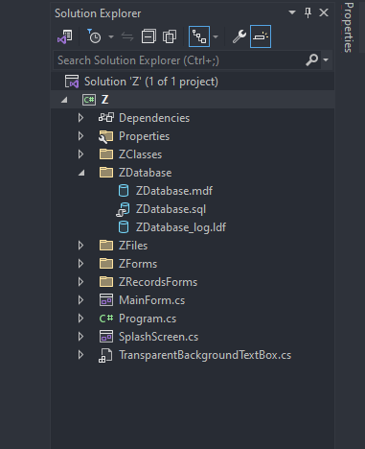

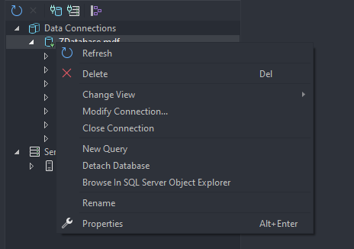in server explorer click the properties of Zdatabase.mdf

Get the connection string ctrl + a and ctrl + c

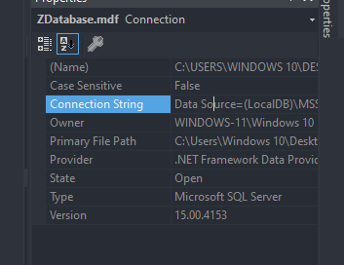

In ZClasses Folder go to app.config

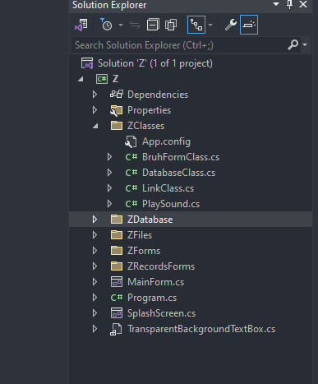

Change the connection string to your connection string

